# Help : How to use “Debtor - Knock Off History”

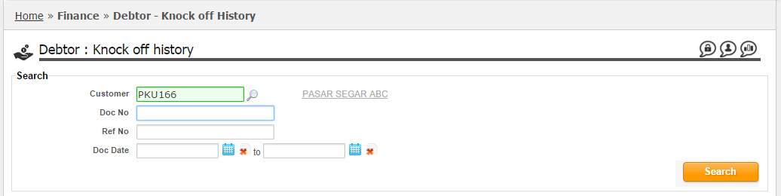

In the “Search” section, you may input the customer code, document no, ref no or date range to search the bill(s) you would like to inquiry about the knock off history.

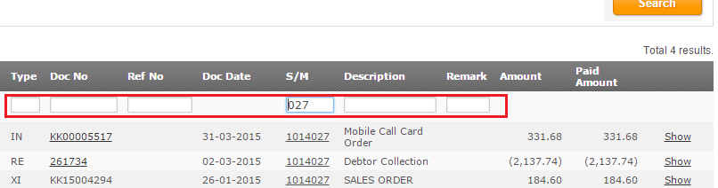

In the search result, you may further filter by using the highlighted section as above.

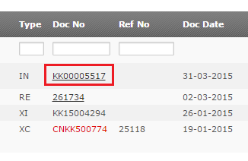

Clicking the document link will redirect you to the related document page in a new window.

*Note: Documents without link are imported data from 3rd party system.*

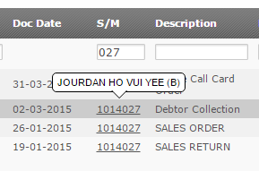

Mouse over to salesman code will show up the respective salesman full name.

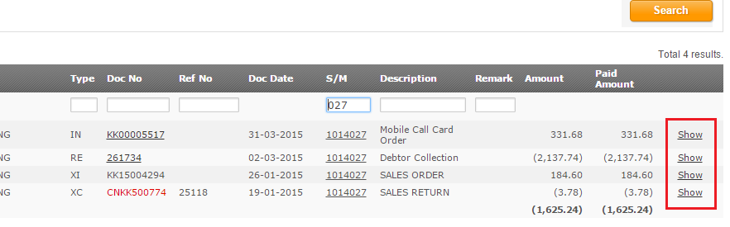

Clicking the “Show” link will lead you to the knock off history for this bills in the section below.

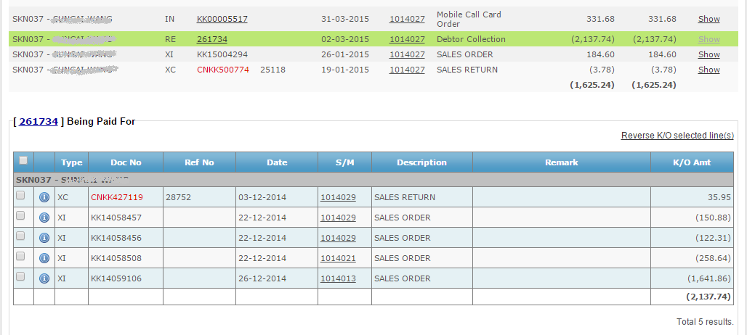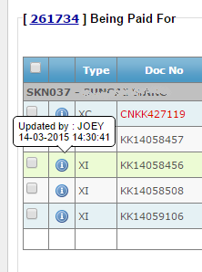

Mouse over to the icon information of user who perform the knock off operation and date time will be displayed.

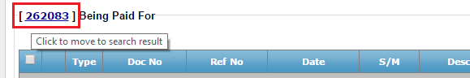

You may click on the document link to quickly move back to the document row at search result above.

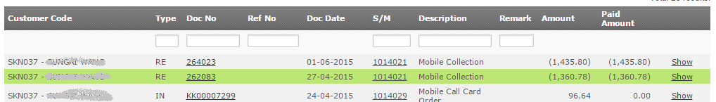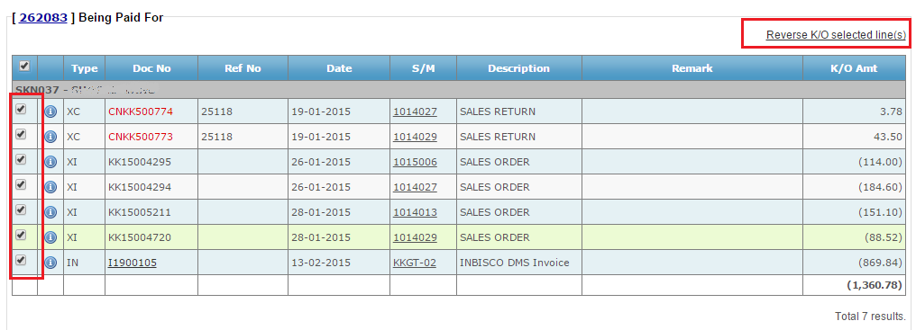

To perform reversal of knock off bills, check the checkbox(es) on the left side, and click on the “Reverse K/O selected line(s)” link.